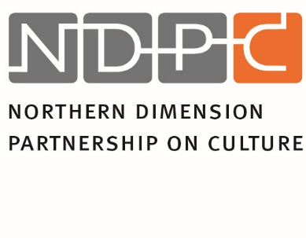
ANNUAL REPORT 2015

Introduction

This report is based on the NDPC Action Plan 2015, adopted by NDPC Steering Committee on March 24-25, 2015 in Helsinki. The Action Plan follows the overall aims of the NDPC set forth by the NDPC Memorandum of Understanding of May 20, 2010 and the NDPC strategy for 2012-2016. The NDPC also bases its work on the NDI report 11 Dimensions: Cultural and Creative Industry Policy Development and Practices within the Area of NDPC (2015).

As of the a.m. documents, NDPC focuses on:
- Networking on various levels, including policy makers, CCI intermediary organisations and stakeholders, international organisations, etc;
- Knowledge activities: studies and research, exchange of best practices;
- CCI promotion, development, access to funding;
- Information exchange and communication
In accordance with the priority lines set by the NDPC strategy:

- Serving as a focal point (1);
- Supporting priority projects (2);
- Facilitating access to project financing (3).

The Main Objectives for 2015, according to Action Plan:

The establishment of a formal, legal basis for the partnership in a Legally Binding Agreement (LBA) will be a priority task in 2015. Meanwhile, continuation of the Memorandum of Understanding (MoU) should safeguard the existing collaboration. The main challenge with LBA is ensuring participation of the countries party to the MoU. NDPC contents work will be continued, basing on NDPC’ s experts’ work results and conclusions and recommendations of the study developed by the Northern Dimension Institute (NDI). Networking events will focus on furthering CCI cross-sectorial collaboration and development.

Main actions as planned for 2015 along the lines of groups of tasks were divided into Administrative tasks, CCI promotion and development tasks, networking activities, knowledge activities and CCI funding initiatives.

1. Administrative Tasks

  - Legally Binding Agreement – finalising the LBA procedures:
    - Clarifying national participation and contribution to NDPC;
    - Clarifying issue of Russian event/institution within the auspices of the NDPC activities;
    - Establishing permanent NDPC Secretariat and clarifying the relevant legal issues;
    - Employment of the Head of the Secretariat.
  - Prolongation of Memorandum of Understanding of NDPC.

The principal agreement on the establishment of the international NDPC Secretariat took place in 2015, however the timing of this agreement did not permit enough time to proceed the LBA at the national governments. The signing of the LBA by all partner countries is expected in 2016, consequently as well as employment of Head of Secretariat and other legal procedures. The countries confirming their participation at the LBA as for the end of 2015 are: Finland, Latvia, Norway, Poland, Russian Federation and Sweden. The LBA foresees that the NDPC Secretariat is based in Riga; the LBA remains in force for five years and will be automatically prolonged unless otherwise decided. Signing the LBA implies not only active participation at the NDPC work, but also confirmed financial contribution. The Latvian government who will be hosting the Secretariat has to create and provide the host country agreement as well as other legal support documents where necessary.
The LBA also foresees that Russia will host an annual NDPC Forum in St. Petersburg (currently within the St. Petersburg International Cultural Forum) with involvement and support of other NDPC countries to benefit the NDPC overall development.
Memorandum of Understanding (MoU), the founding document of the NDPC expired on May 20, 2015. MoU was prolonged by silent procedure for another five years, to be again automatically prolonged unless otherwise decided by the partner countries. Members of MoU are all partners of LBA (as above) and the five countries which at the present moment have not expressed their will to be party to LBA: Denmark, Estonia, Germany, Iceland and Lithuania. All MoU partner countries are equal to take part at the activities of the NDPC; some of the countries have expressed possibility of voluntary contributions despite not being part of LBA, however, only the LBA parties have full voice in the Steering committee decision making.

2. CCI promotion and development tasks

2.1. NDPC strategy for CCI promotion and development
Basing on the Contents’ Working Group (WG) discussions in 2014 and the results of the study of the Northern Dimension Institute (NDI) 11 Dimensions. Cultural and Creative Industry policy development and practices within the area of NDPC it was planned to develop clearly focused NDPC contents strategy, priorities and start its implementation. The study has been published online on www.ndpculture.org, as well as distributed in print at the events NDPC organized or took part (more information about the study below). The study and strategy plans had been discussed among NDPC partners during the year 2015. Some strategic issues had already been commenced to implement, such as the formation of LBA and prolongation of MoU; clear vision on knowledge – based development and necessary further advance in studies and research; conscious collaboration with knowledge – based institutions, such as NDI; establishing the tradition of the NDPC St. Petersburg Forum (2nd Forum in 2015); as well as more focused collaboration with other Baltic Sea Region organisations that also have culture and creative industries in the centre of their interest. However, as some issues had not yet been finalised – such as signing of the LBA, or some contents issues, f.ex. the exact format of NDPC Network of Networks event. It is planned to come up with a new NDPC strategy 2017 – 2020 by the end of 2016.
As to the conclusions of the NDPC’s 2014-15 Contents’ working groups, the main strategic lines of NDPC development should be: Knowledge development, Policies’ development, Network development and Cross-Sector collaboration development.

2.2. Steering Committee meetings

NDPC Steering Committee (SC) meetings are the crucial in ensuring NDPC development, creating NDPC strategies, generating synergies between countries and ensuring the balance of interests, as well as providing ties with other regional organisations and regular feedback and suggestions for future developments.
Three NDPC SC meetings were held in 2015. Before the 20th SC meeting that took place in Helsinki, a meeting of the so called Contents’ working group and also Task Force on LBA was held in Riga on February 9 and 10. The working groups discussed respectively the NDPC contents’ work strategy, summing up the work of 2014; and the matters to be agreed regarding the agreement on establishing the international Secretariat of the NDPC.

The 20th SC meeting took place in Helsinki, Finland on March 24-25, 2015. The main issues to be discussed were: LBA issues; NDPC further contents’ work, including the events to be organised; the action plan and budget for year 2015 were adopted. The 2nd day of the meeting was fully dedicated to the legally binding agreement, and the agreement was reached between the partners about all main issues of the document. The NDPC events: Network of Networks event was proposed to be a back to back conference to Game Development event, organised in collaboration with VIPO to be held at the beginning of November in Krakow, Poland; the 2nd NDPC Forum to be held in St. Petersburg within the framework of International Cultural Forum in December.

The 21st SC meeting took place in Gdansk, Poland within the framework of Baltic Sea Cultural Gathering Conference – the event organised by CBSS Polish Presidency. It discussed the status of the LBA in NDPC partner countries, the funding issues after signing the LBA; possibilities of attracting potential EU funding for NDPC activities/ projects; as well as planning of the Network of Networks event and the St. Petersburg Forum. Due to appearance of various similarly – profiled CCI conferences during the year, it was decided to hold a Focus Group meeting in Krakow of NDPC experts instead of larger Network of Networks event, to assist NDPC to formulate a more specific niche or CCI support that would bring maximised benefit for CCIs in the region with the comparatively minimal resources available to NDPC, as well as potentially measurable results. The Chairmanship of NDPC is to be passed to Russia from the next SC meeting (22nd) throughout 2016, with Sweden as co-chair.

The 22nd SC meeting was organised in St. Petersburg, on December 18 after the 2nd International Forum Culture as Factor of Growth in the Framework of NDPC. During the meeting the results and recommendations of the NDPC Experts’ Focus Group in Krakow were presented to the SC by chair of the expert group Agata Etmanowicz; the LBA status in various countries was discussed. The meeting also discussed the plans for year 2016 work and the budget for 2016. The draft action plan and the budget were adopted, with some issues to be thought over by partner countries and decided during the first SC meeting to be held in 2016 (23rd meeting) before the last week of March 2016. It is planned that the LBA could be signed by mid-2016, as well as new strategy for 2017 – 2020 elaborated during the year.

2.3. Other NDPC events

2.3.1. Round Table Creative Industries within the Northern Dimension Business Forum on March 26, 2015, St. Petersburg,
Russia at the ND Forum Interregional Cross- Border Cooperation in the Changed Reality: New Approaches in Business Development and Interaction within Civil Society.
The Round Table had following presentations: Artlab presentation on CCI mapping in Denmark; Future needs, trends, possibilities for CCI sector – Creative Industries Finland; Smart Moscow – Education and Entertainment in the City by Lisa Kiseleva, Russia; Investment in development of Cultural tourism in city of Cherepovets by Oksana Lukyanenkova, Agency of Urban Development. Discussion of CCI and business representatives.
The Conclusions of the Round Table included the following: CCIs can play great role in regional development, tourism and branding; Usage of digital contents in all spheres of life, including tourism development, healthcare, education and edutainment and other sectors can provide huge opportunities for development; CCI role in social innovation and business development is growing and has large potential. The CCI and business collaboration should be further facilitated.
2.3.2. NDPC Focus Group of NDPC Experts workshop, November 3, 2015, Krakow, Poland.

Recommendations of the Workshop in brief: Different directions were discussed but it was pointed many times that there’s a need for finding a niche, specialisation for NDCP in the competitive market of existing international initiatives, networks and programmes. With limited financial resources, this would be a smart/reasonable choice to make.
The discussion indicated that specialisation, direction for NDCP, might be an investment in professional development of CCIs from ND region. Becoming a “go to” place for new knowledge, up to date information, share experiences, while building partnerships among practitioners from ND countries.

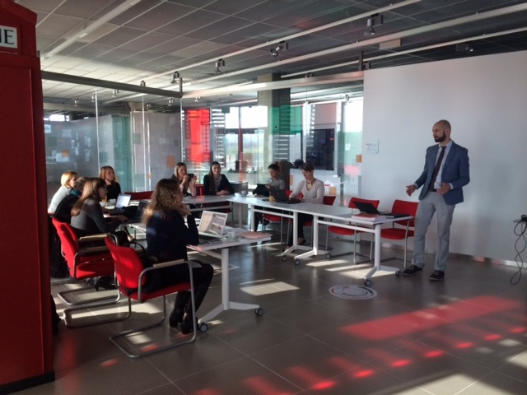
Photo: Focus Group Workshop, Krakow

2.3.3. 2nd International Forum Culture as Factor of Growth in the Framework of NDPC, December 16-18, 2015, Russia.

The Forum had three main topics for discussion: Innovative approaches in the use of cultural resources as a potential for the economic growth of regions and territories; Studying and adapting models of federal and municipal support for small and medium-sized business in the realm of arts and creative pursuits, the federal and regional experience; New educational practices as a driver for building creative environments and territory development – with Russian as well as NDPC countries’ experts taking part at the panel discussions and presentations.
After the Forum, parallel to the NDPC SC meeting a Workshop was held on the subject Audience Development for the local CCI workers, workshop was co-organised by NDPC, NDPC’s Polish and Russian experts, and was arranged in collaboration with Danish Cultural Institute in St. Petersburg.
The conclusions of the Workshop include the following statements: This initiative has potential and is able to become an informal but important platform for networking, collaboration and discussion for professionals in CCI and neighbouring fields in the Baltic region. In Russia at the moment there is no similar initiative that could get together main market players, public institutions and representatives of European public organizations and funds. There is an obvious demand from stakeholders for such kind of gathering and live discussion which can include elements of workshop, lecture and training the NDPC mission can be presented more precisely it is mission in the region can be promoted among stakeholders. Both organizers and participants can benefit from it and complement each other with various types of resources.

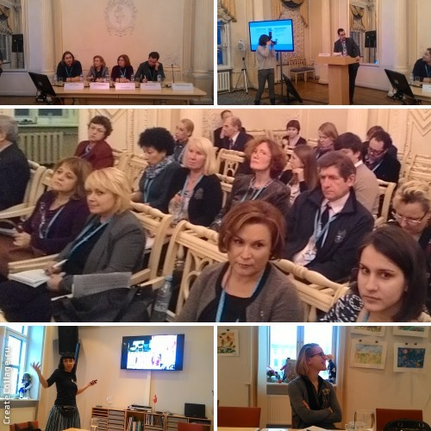
Photo: Forum in St. Petersburg and Workshop

3. Network activities

One of the main aims of NDPC for 2015 was to continue network collaboration by all NDPC countries and stakeholders on all levels (national, regional, international) to facilitate CCI development in the NDPC area.
In order to implement this aim and also inform about and promote the work of NDPC, NDPC and the Secretariat took part at various regional events, for example:

- Meeting at CBSS headquarters, Stockholm, April 27 on developing regional collaboration projects within cultural tourism. As one of the results of this meeting – collaboration with NGO Norden of Russia discussed and agreed during the year on a wider Baltic Sea Region project on culture, cultural tourism and innovation.
- 4th Northern Dimension Parliamentary Forum, May 10-11, Reykjavik, Iceland.
- NR Steering Group meeting, May 28, Brussels, Belgium.
- 6th Forum of the European Strategy of the Baltic Sea Region Achieving E-Quality by Connecting the Region, June 15-16, Jūrmala, Latvia.
- NDI Steering Group meeting, September 8, Helsinki, Finland.
- Baltic Sea Cultural Gathering Forum, CBSS, September 15-18, Gdansk, Poland.
- Creative Future/ Nordic Summit 2015, November 30 – December 1, Helsinki, Finland.
- Northern Dimension Day, December 9, Brussels, Belgium. This event was organised by NDI to promote ND partnerships, including NDPC, their work results and perspectives. All ND partnerships, NDI, EU, representatives of ND countries and other interested parties were represented.
- Several meetings with European Commission in Brussels during the year in order to inform, promote NDPC and discuss possibilities of additional funding from EU sources.

In addition, within the network collaboration by all NDPC countries and stakeholders on all levels (national, regional, international) to facilitate CCI development in the NDPC area a following project by the Finnish Chairmanship of the Barents Euro-Arctic Council was “Barents Cultural Initiative Incubator” was carried out:
In the beginning of 2015 a one year project was launched in the frame work of the Finnish Chairmanship of the Barents Euro-Arctic Council. The NDPC SC was informed about the project and it was included in the NDPC AP 2015. All together five projects were selected for further development of their project plans with a view to apply for further funding: 1. Barents Artists Mobility Platform project, 2. Sami Design Archives project, 3. Mining our Mind & Culture in Mining project, 4. The Industrial Age museum project, 5. Environmental art to tourisms sites cultural tourism project, 6. Arts unites people art education project. All together 37 participants took part in the incubator´s 2nd session. Project succeeded to provide innovative environment and good practical tools for project planning. Project was co-financed by the Ministry for Foreign Affairs of Finland.

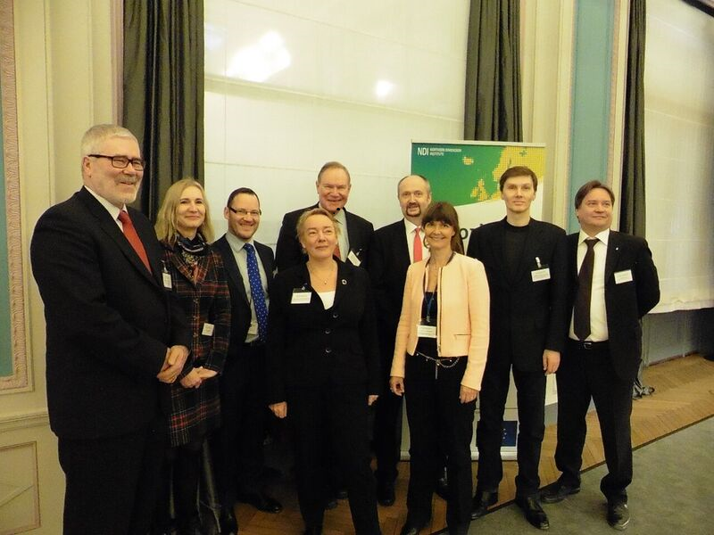
Photo: ND Day in Brussels – ND partnership representatives and Mr. Paavo Lipponen, the
former Prime Minister of Finland

4. Knowledge activities (Knowledge production, knowledge dissemination, information)

4.1 2015 - Finalising NDI CCI study 11 Dimensions. Cultural and Creative Industry policy development and practices within the area of NDPC, publishing and distribution.
Northern Dimension Institute (NDI) study on CCI policies in the ND region, CCI development’s best practices and challenges in the ND area was commissioned and co-financed by the NDPC in 2014- 2015. The study was closely linked to the development of the NDPC’s own development of its Contents’ strategy, and was quite crucial for the development, aimed to be knowledge – based.
The study was commissioned with an aim of facilitating the efforts of NDPC to contribute to improving the operating conditions for cultural and creative industries and strengthen the cooperation in the field throughout the ND region. For NDPC it is essential to have an accurate picture of the prevailing situation in the region. In order to achieve this, an analytical study was needed. The study would form a basis for building a common vision within the NDPC on the focus areas of its future activities and further information needs. The study:
- Gives a broad view on CCI policies in the NDPC region by analysing them from cultural, educational, economic, employment and innovation policy perspectives. This gives important insight to main focuses, differences and similarities from a broad perspective as well as identifies possible gaps or needs for further policy work.
- Identifies the relevant actors and networks in the NDPC region and view the CCI policies and actions from their perspectives. Their needs and demands vary, as do their potential outputs as a part of the ecosystem.
- Identifies the main challenges, best practices, tools and results achieved in the CCI policy development within the NDPC region and comes up with recommendations for the NDPC on further development of policies and interventions.
The study is available on www.ndpc.org in the section of Publications by NDPC. Printed booklets are available at the NDPC Secretariat.

4.2. NDPC information activities

NDPC had been surveying news and events on regular basis regarding CCI activities in the Baltic Sea Region, posting 150 news articles and information both about NDPC activities and events, as well as other relevant CCI material on NDPC web site during 2015.
The NDI/ NDPC study 11 Dimensions. Cultural and Creative Industry policy development and practices within the area of NDPC was made available on the NDPC web-page, as well as a virtual libraries of other international CCI studies/ reports. The study 11 Dimensions had also been printed and distributed at all NDPC events, as well as events and meetings NDPC had taken part. Three newsletters had been published that reached audience of 600. NDPC has been providing information to the NDI newsletter about the activities and developments of all ND partnerships.
Meanwhile, during the NDPC Focus Group meeting in Krakow one of the issues for discussion that NDPC raised was about the development of the NDPC communication policy and communication contents. As the result of it, it was decided to re-examine the current homepage concept and re-develop it, as well as start working on communication more pro-actively, also adding social communication channels in 2016.

5. CCI funding initiatives

In 2015 NDPC finalised support to the EU co- financed NDPC CCI projects of the 2nd Project Call: Filmteractive Festival Network (Lodz, Poland); Creative Business Cup – Now with Russia (Denmark); Arterritory (Latvia); Estonia – Finland- Russia Music Industry Platform Partnership (Tallinn Music Week, Estonia). All projects were successfully completed, and for some of them, especially the Filmteractive Network – the NDPC support had been crucial for reaching self- sustainability. Filmteractive project was also presented at the ND day in Brussels as one of the success stories of ND partnerships.
NDPC has also been working towards attracting additional funding outside NDPC countries’ individual contributions for developing NDPC activities. As the result, an agreement with the European Commission had been signed at the end of 2015 on supporting some of the NDPC’s operational activities, including informational activities. Also, a study on how CCIs can foster innovation in tourism has been commissioned by the EU and will be carried out within 2016.

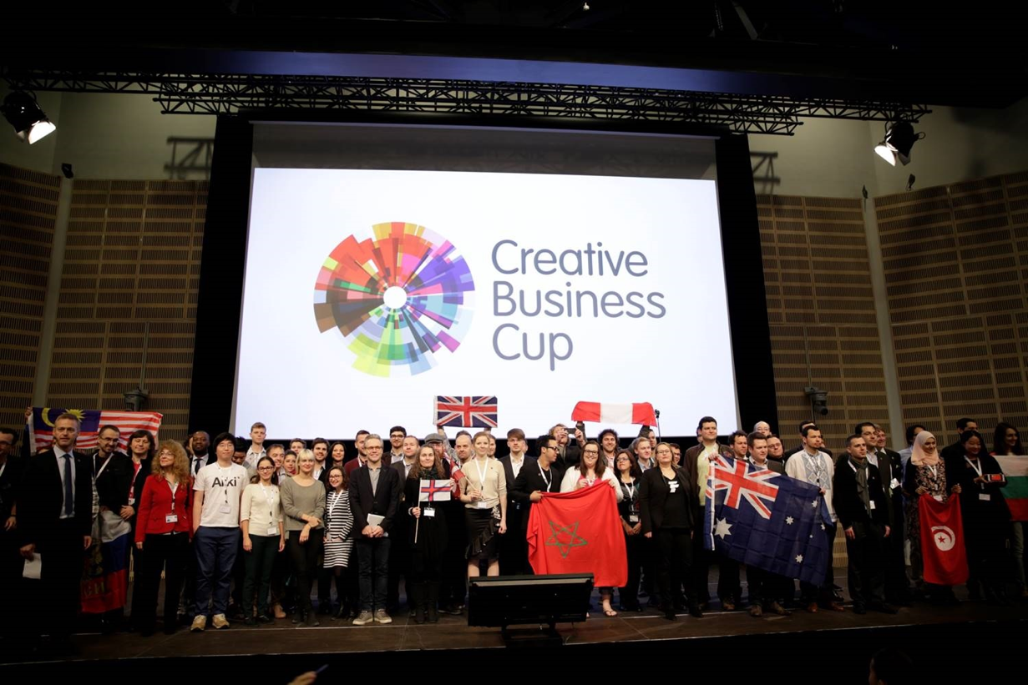
Photo: Creative Business Cup

6. The Main Objectives of 2016

The signing of the Agreement on establishing the NDPC international secretariat is still a priority task in 2016. NDPC contents work will be continued, basing on conclusions and recommendations of the study developed by the Northern Dimension Institute (NDI) - 11 Dimensions: Cultural and Creative Industry policy development and practices within the area of the Northern Dimension Partnership on Culture.
Further NDPC development strategy for 2017- 2020 is planned to be elaborated.
A new study will be carried out in 2016: Mapping Exercise: How Could Creative Industries Foster Innovation in Tourism in the Northern Dimension Area?, financed by the EU.
Networking events will focus on furthering CCI cross-sectorial collaboration and development. Recommendations by NDPC focus group will be taking into account when creating and organising events, in communication, as well as other activities.

NDPC Secretariat,
Ilze Gailite Holmberg
Nordic Council of Minsters’ Office in Latvia
Marijas iela 13/3, LV 1050, Riga, Latvia ndpc@norden.lv; Ilze.Gailite.Holmberg@norden.lv www.ndpculture.org

