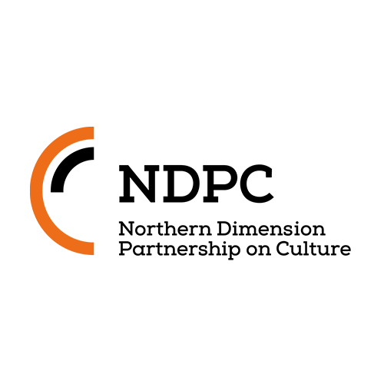
ANNUAL REPORT 2017

Introduction

The action plan of year 2017 was based on the newly developed NDPC strategy for 2017-2020 and followed the overall aims of the NDPC set forth by the NDPC Memorandum of Understanding of May 20, 2010, prolonged in 2015.

Vision of the NDPC
Culture and creativity is a driving force in regional and international sustainable development and a cornerstone for cooperation in the ND area, setting a collaboration framework in wide spheres of society and facilitating social inclusion through means of culture and creativity.

Mission of the NDPC
The mission of the NDPC is to contribute to social and economic sustainable development, and innovation and diversity in the ND area by focusing on the operating conditions for cultural and creative industries (CCIs).

The central aims of the NPDC include:

- Promotion of and benefitting from the diversity of the CCI field in the ND area.
- Facilitating development of sustainable and effective policies and incentives.
- Connecting and building synergies between CCI stakeholders and other relevant societal actors throughout the entire ND area.
- Bridging the gap between public and private funding and strengthening cooperation between the CCIs, policymakers and business communities.
These aims are not exclusive, but do complement each other. Further objectives can arise on the basis of these aims on a more actual basis.
The aims should be carried out:
- By developing national and regional policies and activities basing on knowledge, communication and information exchange.
- By developing and utilising networks on regional and national levels.
- By supporting, developing and promoting collaboration projects.
- By furthering CCI development and accessibility to culture and cultural heritage through the possibilities presented by technological developments.

NDPC’s main focus areas of the practical work are:

- Networking on various levels, including policy makers, CCI intermediary organisations and stakeholders, international organisations, etc;
- Knowledge activities: studies and research, exchange of best practices;
- CCI promotion, development, access to funding;
- Information exchange and communication.

- The Main Objectives of 2017

The signing of the Agreement on establishing the NDPC international secretariat was one of the priority tasks in 2017.

NDPC contents work was to be continued, basing on conclusions and recommendations of the study developed by the Northern Dimension Institute (NDI)-”11 Dimensions: Cultural and Creative Industry policy development and practices within the area of the Northern Dimension Partnership on Culture” and the “Mapping Exercise: How Could Creative Industries Foster Innovation in Tourism in the Northern Dimension Area?” by Proman.
Within the contents ’work NDPC planned to continue the collaboration with NDI, involve in its work industry representatives, as well as CCI networks and experts; aimed to organize new or join existing formats& events that gave practical and measurable impact on CCI development.

In collaboration with NDI NDPC aimed to work on new projects for development, creating synergies and research, for example, EU Baltic Sea Region seed money application and other projects.

In knowledge base development NDPC was to continue to work with the NDI and other relevant actors in order to research, exchange information and utilize potential common resources.

Networking events were planned to focus on furthering CCI cross-sectorial collaboration and development. Existing events such as workshops within the ND Forum/ Business Forum and NDPC Forum in St. Petersburg – the key NDPC annual event - were to continue their development. Within the ND Business Forum a workshop with focus on Digital Innovation& CCIs for Businesses was planned to be developed.
NDPC planned to join and provide additional value to the Latvian Creativity Week RADI!
Other CCI events were to be developed or supported upon decision of the NDPC Steering Committee.

In 2017 NDPC planned synergetic collaboration with other organisations and networks with focus on CCI development and cross- sector collaboration.
In 2017 the NDPC Chair country was Sweden. The budget of the NDPC is comprised by the NDPC partner countries’ contributions, as well as additional funding raised for NDPC projects by the Secretariat.

- Main actions 2017

  - Administrative tasks

Legally Binding Agreement – finalising the LBA procedures and signing the LBA:
Six countries out of the 11 original Memorandum of Understanding partners had agreed to be part of the LBA: Finland, Latvia, Norway, Poland, Russian Federation and Sweden. In 2017 five of them had carried out the necessary national procedures to be ready to sign the LBA. Polish partners had additional procedures in 2017 of the LBA within Poland’s Government structures; as the result some editorial changes to the LBA text had been suggested by Poland. These changes had been discussed by NDPC and a new time-frame set forth for signing of the LBA during 2018.
Work on future collaboration and funding projects:
During 2017 the Secretariat and the NDPC worked towards development of new projects, new collaborations and new synergies. Project Creativity, Digital Innovation and Cultural Tourism: Synergies, Network and Capacity Building (CreaDigi&Tourism ) was developed for BSR Interreg Seed Money programme together with Northern Dimension Institute/ Aalto University and National Association of Creative Industries of Lithuania and received seed funding for further project development. CreaDigi&Tourism project meetings were held in the fall of 2017 and stakeholder needs and project contents discussed.
Together with CCI and municipal partners in Russia and Latvia a project Arts& Crafts & Gastronomy – Creativity for Future was developed for Latvia – Russia cross-border collaboration programme with an aim to source on the rich creative heritage for future developments of regions, involving NDPC expertise.
Collaboration with Culturability project continues where NDPC shares its expertise and is an associate partner for Culturability’ s further development (also below, in section of development of projects and synergies).
The project Residency Network Hub for Cultural Intermediaries (06/2016 – 11/2017) was executed successfully in order to support and develop networking and project development for CCI intermediaries such as producers, managers, curators and residence professionals. The main target was to increase mobility and exchange of information with a view to promote mobility of immaterial capital, skills, projects, artists, artistic productions and exhibitions in the ND area. The last workshop of the project was coordinated together with the NDPC Annual Forum and took place at the same time in St. Petersburg.

  - CCI promotion and development tasks
- Develop NDPC communication.
- Develop NDPC website and newsletters, work in social media.
- Promote NDPC studies.
- Work with NDI and other organisations on development of synergy projects and mutual collaboration.

NDPC Communication, promotion of studies and development of projects
NDPC web site www.ndpculture.org continued its development into more up-to-date and easily perceivable format, with NDPC and industry news. NDPC continued its communication through Facebook on regular basis. NDPC issued four newsletters in 2017, with primary focus on NDPC related news but also other news and events relevant to NDPC. The newsletters have the regular audience of 640 recipients. Message on NDPC work and strategies was communicated during NDPC events, as well as events and meetings where NDPC took part.
On communication side NDPC also worked with other organisations concerned with CCI development providing information on its activities and work with project development.
NDPC studies, namely, 11 Dimensions: Cultural and Creative Industry policy development and practices within the area of the Northern Dimension Partnership on Culture” and the “Mapping Exercise: How Could Creative Industries Foster Innovation in Tourism in the Northern Dimension Area?” were promoted and distributed during NDPC events and meetings where NDPC took part. During NDPC Forum in St. Petersburg approximately 200 copies of the “Mapping Exercise…” – reports on Russia and Cross-country reports were distributed to the participants of the Forum. The reports were highly appreciated by the Forum participants and CCI experts, noting them being of quite unique nature.
During 2017 NDPC worked towards development of new projects, new collaborations and new synergies. Project Creativity, Digital Innovation and Cultural Tourism: Synergies, Network and Capacity Building (CreaDigi&Tourism ) was developed for BSR Interreg Seed Money programme together with Northern Dimension Institute/ Aalto University and National Association of Creative Industries of Lithuania and received seed funding for further project development. CreaDigi&Tourism project meetings were held in the fall of 2017 and stakeholder needs and project contents discussed.
Together with CCI and municipal partners in Russia and Latvia a project Arts& Crafts & Gastronomy – Creativity for Future was developed for Latvia – Russia cross-border collaboration programme with an aim to source on the rich creative heritage for future developments of regions, involving NDPC expertise.
Collaboration with Culturability project continues where NDPC shares its expertise and is an associate partner for
Culturability’ s further development.
NDPC attended the first Arctic Arts Summit in Harstad, Norway where work was done to develop contacts and synergies.
Throughout the year continuous work had been done in collaboration with NDI to seek for new ideas, new projects, new developments in the CCI and CCI – cross sectorial field within the ND area.
New project Refinery of Sustainable Cultural Tourism Products in the Northern Dimension Area (01/2018 – 06/2019) was developed by the NDPC Finnish partners, planned to be a creative meeting place for actors working in the field of culture and tourism industry with a view to facilitate developing of high quality cultural tourism products and services in the ND area. The main objective of the project - to enhance business and entrepreneurial possibilities in cultural tourism by creating sustainable arts and cultural tourism products and services. Project facilitates the Finnish Chairmanship in the Northern Dimension Partnership on Culture Steering Committee.

  - Network activities
To continue network collaboration by all NDPC countries and stakeholders on all levels (national, regional, international) to facilitate CCI development in the NDPC area and support sustainable cultural tourism products in the ND area.
- ND Forum/ ND Business Council – CCI and business meeting & workshop – focus on digital innovation & creativity for business development.
- NDPC Forum within the St. Petersburg International Culture Forum.
- Other NDPC priority activities/projects (Radi!).

    - Steering Committee Meetings.
During 2017 three regular Steering Committee meetings took place. One working group meeting, dedicated to organisation of the NDPC Forum in St. Petersburg took place.
26th SC meeting took place in Avesta, Sweden, February 27-28. The most important issues discussed during the meeting: the 2017 – 2020 NDPC Strategy was approved; the 2017 Action plan and budget were approved; Annual Report of 2016 discussed; project Radi! of Latvia presented and discussed; status and signing issues of LBA reiterated; internal regulations for NDPC projects discussed and approved. The SC was got introduced to the creative hub/ incubator Verket, its work and development through years, as an example of development of former industrial places to creativity excellency. Together with representatives from Verket, the SC also shared good examples of CCI and tourism cooperation in rural areas.
27th SC meeting took place in Berlin, June 13 as back – to – back meeting with the 8th Annual Forum of the EU Strategy for the Baltic Sea Region. SC Meeting took place after the Joint Meeting of CBSS SO for Culture, NDPC SC, ARS BALTICA organising Committee, EUSBSR PA Culture and Creative Sectors SG where the NDPC partners participated. Issues discussed were: LBA signing revisited; issues of Host Country Agreement in connection to LBA; plans for NDPC Forum in St. Petersburg, November 2017; Radi! project news.
28th SC meeting took place during the 4th NDPC Forum on November 17 in St. Petersburg. The Agenda of the meeting comprised the following issues: status of the LBA; Host Country Agreement procedures; upcoming Finnish Chairmanship of the NDPC and plans for 2018; presentation by NDI of the ND Future Fora idea; NDPC presentation at the European Parliament on November 22.
On September 7 in Moscow a thematic meeting took place in connection with preparation to the NDPC Forum, discussing the contents of the Forum, potential experts from NDPC countries and organisational issues.
2.3.2. Northern Dimension Forum “New technologies and how they shape life”.
8th ND Forum, took place on April 6, 2017, St. Petersburg. During the Forum NDPC organised a round table “New Creativity & Technologies for Business Development”
The Round Table focused on technical and creative innovations – on how new technologies help creativity and cultural/ creative industries (CCIs) to create new advanced products and services, new level of public accessibility, new audiences. The focus of the Round Table was public sector and mostly non – commercial activities, education, social inclusion and integration.
There were four presentations during the Round Table, followed by a discussion with the audience:
- “Kaykino creative projects” by Olga Gracheva, Founder of the Projects, Russia (project was represented by Ms. Natalia Vavilova).
- “Joining creativity” Project by Kseniya Chumak, Deputy Head of Karelian Resource Centre of NGO’s, Russia.
- Digital technologies and museums: the experience of Severstal by Natalia Poppel, Severstal, Russia.
- Digital Applications for Public Institutions, Renars Jansons, Cube, Latvia.

2.3.3.4th NDPC Forum within the St. Petersburg International Culture Forum.
On November 17-19 the annual NDPC Forum in St. Petersburg Culture as Factor of Growth took place, titled “ New Cultural Routes and Sustainable Development: From Theory to Practice”.
Russian and International experts and guests took part at the Forum to discuss the impact of cultural and creative industries in three conference subsections: “Culture and Creative Industries Meeting Tourism, Economy and Innovations”; “Cultural Projects and New Routes” and “Cultural Tourism and Regional Policies”, finalising the Conference with a Business Game “Cultural Project: Design Tool Kit”.
The Forum participants acknowledged that one of the most important outcomes of the Forum was creation of a regional platform for communication and collaboration within CCIs. The Forum within the four years of its work has become a well-known activity in supporting and sustaining the professional community in the area.
Together with experts the forum participants outlined new vectors for the development of the region, identified tools and methods of cultural project design using the examples of relevant regional and international cases, set a new agenda for the development of the creative tourism in the region and the ways the sector can contribute to efficient cultural policy making. The Forum participants concluded that the role of regions both in Russia and European Union is raising. Rethinking their role as well as discovering, developing and supporting their cultural and creative potential can benefit to sustainable development in the wider Baltic Sea Region. Integration of cultural and creative industries into local and regional development strategies is of utmost importance, as it facilitates the contribution of the sector to wider local socio-economic growth and furthers its role in placemaking - including serving regional audiences, delivering representational content and encouraging local engagement.
    - NDPC’s projects: Radi! Creativity week supported by NDPC.
In 2017 NDPC introduced its internal project support system: NDPC partners can apply to the SC with their priority projects, and the SC can decide to grant co-financing to them, basing on the importance and impact of a project within NDPC priorities’ context. For this, NDPC developed project support guidelines. In 2017 the internal project support was given to Latvian Creativity week Radi!.
From September to December 2017, Creativity week Radi! events were held in Latvia. The aim of Radi! was to highlight achievements, as well as the potential of creative and culture industries and their interaction with other sectors.
The main directions of Radi!2017 were the following: Interaction of creative industries and other sectors, emphasizing their potential and involvement in progressive and innovative entrepreneurship in the context of the development of social well-being, life quality and urban environment of the Baltic sea region; Design thinking methods and an interdisciplinary approach in public administration management and education processes, as well as active involvement of regional inhabitants, minorities and youth, thus focusing on the idea of participation, promotion of interests and strengthening of dialogue. In total, more than 20 events have been held in Riga, regions and also outside Latvia – in the Netherlands – around 700 people have taken part in Radi! activities.

    - NDPC’s participation at other regional fora, events and meetings.
During 2017 NDPC and the Secretariat took part at various regional fora, events and meetings to promote NDPC, to report and discuss visions of future development, to discuss possibilities of collaboration and common projects.
These meetings include: Northern Dimension Senior Officials’ meeting in Oslo in October 2017; meetings with NDI in Helsinki, Turku and Riga during the year on common collaboration projects and their development; meetings and presentations at Baltic Sea Region Priority Area Culture events in Berlin and Kaliningrad; presentations, competence exchange and project collaboration with the international Culturability project, led by Nordic Council of Ministers in Gdansk and Tallinn; St. Petersburg conference Baltic Sea Region: from Planning to Common Actions; presentation by the NDPC Chair at the European Parliament at the 5th Northern Dimension Forum; development of collaboration with Arctic Arts Summit in Harstad and others.

- Knowledge activities
- Promotion and dissemination of the results of “Mapping Exercise: How Could Creative Industries Foster Innovation in Tourism in the Northern Dimension Area?”
- Collaboration with NDI continued; working on development of new projects and studies.

NDPC studies, namely, 11 Dimensions: Cultural and Creative Industry policy development and practices within the area of the Northern Dimension Partnership on Culture” and the “Mapping Exercise: How Could Creative Industries Foster Innovation in Tourism in the Northern Dimension Area?” were promoted and distributed during NDPC events and meetings where NDPC took part. During NDPC Forum in St. Petersburg approximately 200 copies of the “Mapping Exercise” – reports on Russia and Cross-country reports were distributed to the participants of the Forum. The reports were highly appreciated by the Forum participants and CCI experts, noting them being of quite unique nature (as above in NDPC Communications). In Latvia the presentation of the “Mapping Exercise” was followed by a review on the CCI website www.fold.lv. Further dissemination and promotion of the study is planned in 2018.
Collaboration with NDI during 2017 was successfully continued both in form of mutual consultations, information exchange, NDI and NDPC strategy development as well as in development of new common projects. During 2017 NDPC worked towards development of new projects, new collaborations and new synergies. Project Creativity, Digital Innovation and Cultural Tourism: Synergies, Network and Capacity Building (CreaDigi&Tourism ) was developed for BSR Interreg Seed Money programme together with Northern Dimension Institute/ Aalto University and National Association of Creative Industries of Lithuania and received seed funding for further project development. CreaDigi&Tourism project meetings were held in the fall of 2017 and stakeholder needs and project contents discussed.

5. Main Objectives of 2018

The signing of the Agreement on establishing the NDPC international secretariat – LBA - continues to be a priority task in 2018. This should be followed by the necessary transitional procedures – Host Country Agreement by Host country Latvia, legal procedures related to staff, etc.
NDPC contents work will be continued, basing on NDPC strategy of 2017 – 2020, the studies of the previous years and the conclusions and recommendations from the NDPC events, namely, NDPC Forum in St. Petersburg and others.
Within the contents ’work NDPC will continue the collaboration with NDI, involve industry representatives, as well as CCI networks and experts; aim to organize new or join existing formats& events that give practical and measurable impact on CCI development.
NDPC will co-organise the NDPC Future Forum initiated by NDI and the Ministry of Culture and Education of Finland, as part of the Future Fora initiative for all ND partnerships by NDI, co-financed by EU.
The aim of the NDPC Future Forum will be discussing and forecasting future developments, challenges and opportunities of the partnerships, with focus on cross-sectorial developments in CCIs.
During 2018 and 2019 implementation of the new NDPC project Refinery of Sustainable Cultural Tourism Products in the Northern Dimension Area (01/2018 – 06/2019) is planned to be a concrete input for the partnership on behalf of Finnish Chairmanship in the Northern Dimension Partnership on Culture Steering Committee. The main objective of the project is to enhance business and entrepreneurial possibilities in cultural tourism by creating sustainable arts and cultural tourism products and services.
NDPC Forum in St. Petersburg during the fall will be another focal event of the year for NDPC, the theme of the Forum to be decided.
Within the annual ND Forum in ST. Petersburg in April NDPC will organise a Round Table on new management models and business processes.
NDPC Secretariat will continue to work on collaboration projects in the BSR, together with NDI and other partners.
NDPC will continue to work on developing networks with regional organisations of similar profile and interests.

6.Visual reflections of 2018 NDPC work
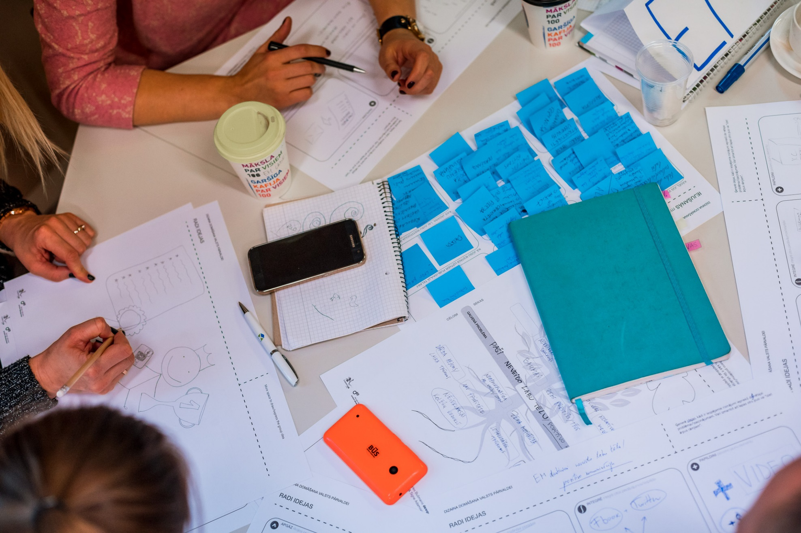
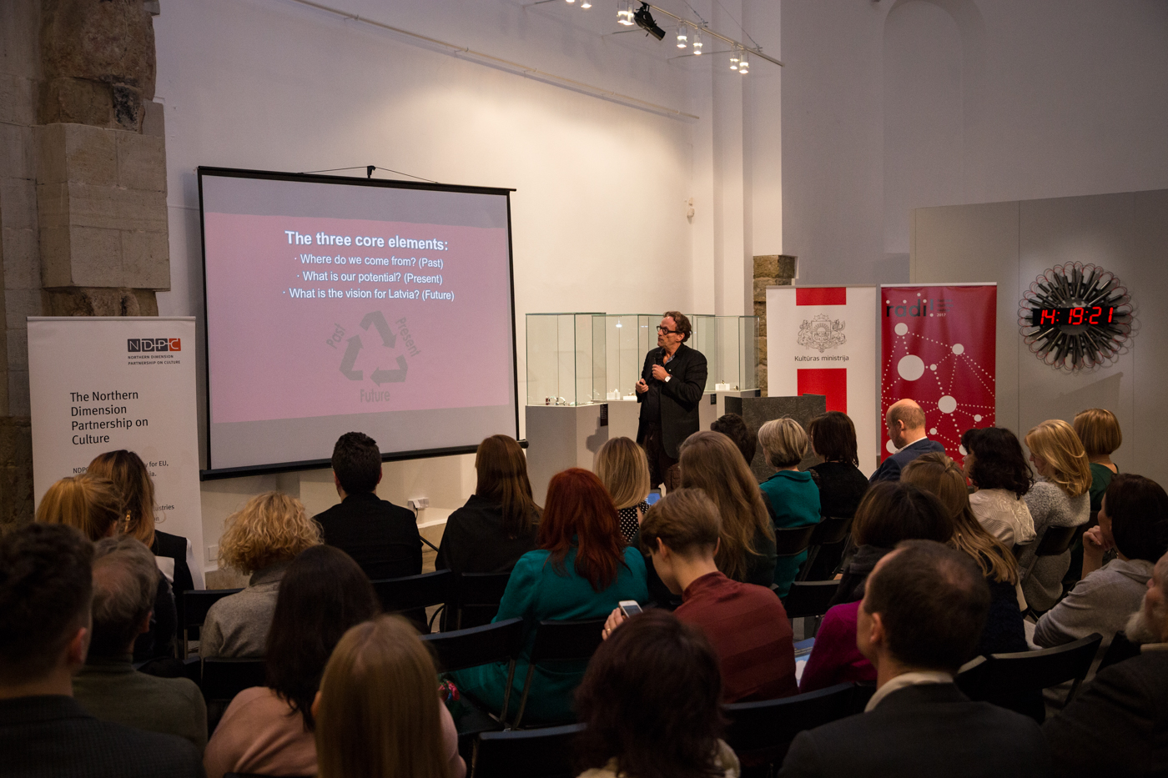
Creativity week Radi! in Latvia, lecture by Christian Have, DK

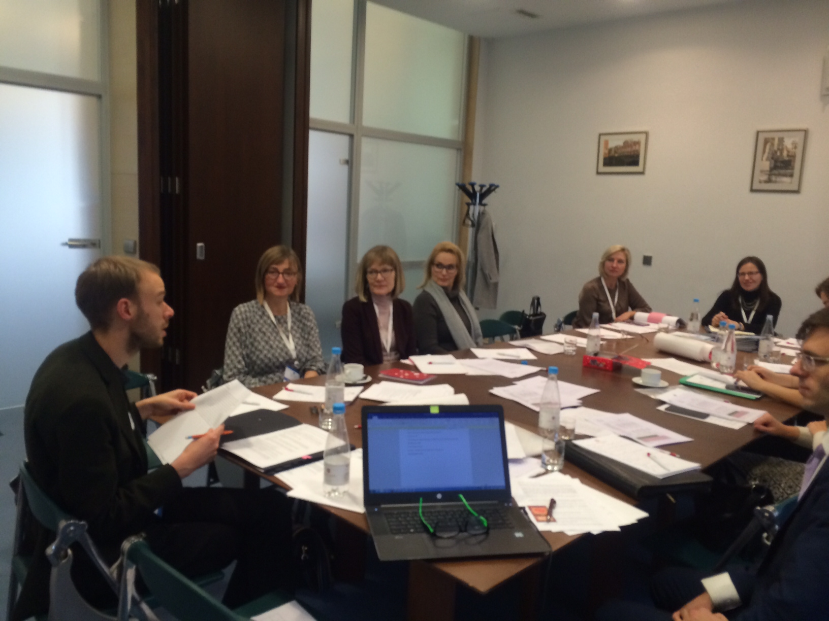
NDPC Steering Committee meeting in St. Petersburg
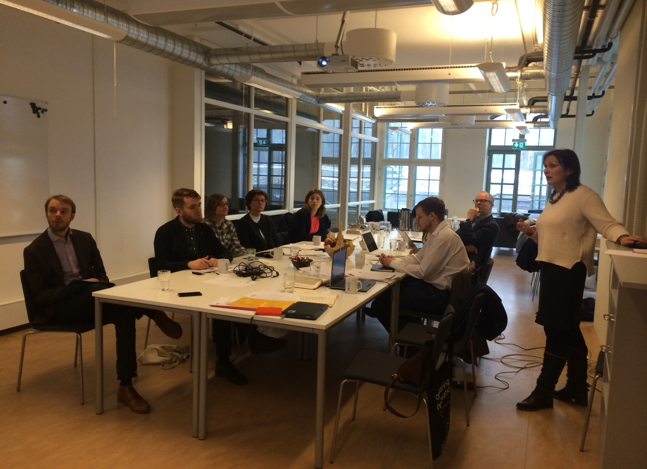
NDPC Steering Committee meeting in Avesta
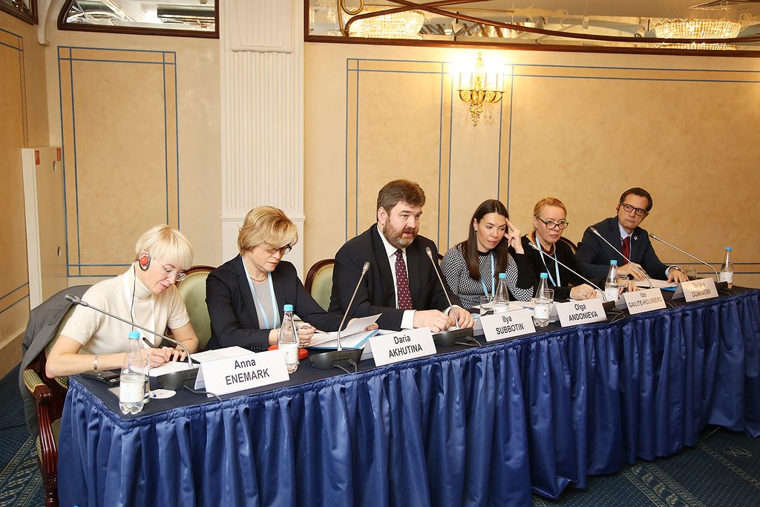NDPC Forum, panel St. Petersburg
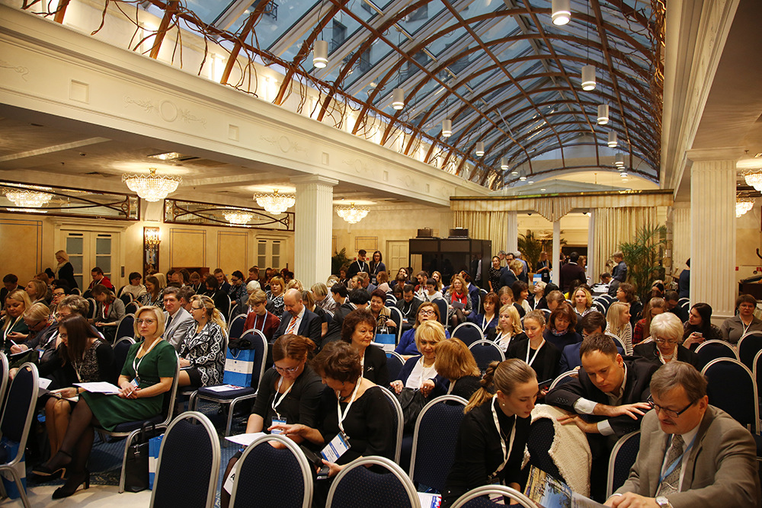NDPC Forum St. Petersburg

